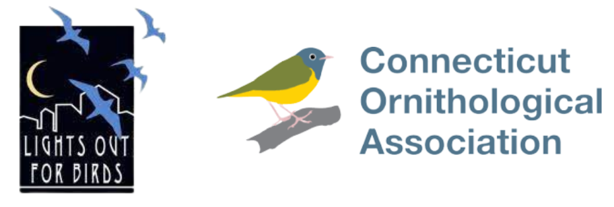
Lights Out Connecticut
Communications Toolkit

For more information, email contact@lightsoutct.org

Overview

Lights Out Connecticut was launched by the Connecticut Ornithological Association in February 2022 to help reduce bird deaths caused by building collisions in the state of Connecticut.
The goal of Lights Out Connecticut is to make Connecticut a more bird-friendly community.
Lights Out Connecticut is a voluntary program encouraging building owners and residential homeowners to turn off or reduce lighting from midnight to dawn during the peak bird migration periods of April 1 to May 31 (spring) and September 1 to November 15 (fall).
Modeled after other successful programs in Toronto, New York City, and Chicago, Lights Out Connecticut is working with building owners, property management companies, tenants, local governments, and homeowners to make Connecticut safe for passing birds. Studies have shown that bird deaths during peak migration periods can be dramatically reduced when exterior architectural and unnecessary lighting is turned off. Lights Out Connecticut has an additional benefit of reducing energy usage and cost to help properties achieve their sustainability goals.
Most birds migrate at night in order to avoid predators and to take advantage of cooler temperatures and fewer thermals. Artificial nighttime lighting can be a major obstacle for migrating birds, which use the moon, stars, and magnetism from the earth for guidance. Nighttime lighting from houses and buildings can disorient birds, causing them to crash into buildings or become trapped in beams of light.
So far, the largest study of bird collisions in Connecticut was conducted at Yale School of Management’s Edward P. Evans Hall. From April 2018 to mid-October 2020, 262 birds of at least 47 species were found dead, stunned, or injured by the building due to window strikes, according to data from carcass surveys and citizen science observations. For more details on the impacts of just one building in Connecticut, see Why Yale's Evans Hall is a Death Trap for Birds and What Can Be Done About It, by Viveca Morris.
For additional information or to download a reproducible Lights Out Connecticut Fact Sheet, please visit www.lightsoutct.org

Draft Op Ed

By [INSERT YOUR NAME]
Each year, millions of birds migrate through [INSERT YOUR CITY/TOWN] in one of the planet’s great wildlife spectacles.
[INSERT A BRIEF STORY OR MEMORY OF 1-2 SHORT PARAS ABOUT WHY BIRDS ARE SPECIAL TO YOU.]
Protecting migratory birds is an easy way to take care of Connecticut. U.S. bird populations are declining rapidly, with devastation to common and rare species across every ecosystem. Due to urban sprawl, tall buildings, highly reflective glass windows and bright lights, an estimated 300-900 million U.S. birds die every year from collisions with buildings and structures.
But the good news is, there’s an easy fix. Everyone in [INSERT NAME OF CITY/TOWN] can help protect our feathered friends by simply turning off their lights at night. During Connecticut’s peak [spring bird migration period April 1 to May 31 /// or fall bird migration period September 1 to November 31], we should turn off all nonessential lights from 12 p.m. to 6 a.m. Each night, each light turned out helps save migrating birds. And as an added bonus, turning off nonessential lights also saves energy for cities, local businesses and homeowners.
Light pollution is a growing and under recognized threat to birds. The light emanating from cities like Bridgeport, Stamford, and New Haven attracts and disorients birds, leaving them confused and vulnerable. Large numbers of light-related collisions have been documented, including at Yale’s Edward P. Evans Hall, in New Haven.
A new program called Lights Out Connecticut was launched in our state in February 2022 to reduce light pollution that endangers migration birds.
Bird collisions can occur at any point during the full spring migration March 1 to June 15, but experts from the Cornell Lab of Ornithology say that the window of [April 19 to May 7 // or September to October 10], when half of the total [spring/fall] bird migration traffic passes through our state, is most important.
As [INSERT NAME OF CONSERVATIONIST OR WRITER YOU LIKE] once shared, “[INSERT QUOTE FROM THIS PERSON].” Birds are critical, and they contribute to humans’ daily life.
Birds control pests, eating 400 million to 500 million tons of insects annually. They pollinate about 5% of the plants we use for food and medicine each year. They maintain diverse ecosystems by spreading seeds through their droppings. Birds help our economy, playing a major role in the ecotourism industry that boosts the United States by more than $100 billion annually. And they’ve sparked innovative ideas. From flight, to navigation, to noise reduction, birds’ example has been paramount to human progress.
So let’s join this effort to protect our birds. Millions of birds migrating through the U.S. will soon fly through Connecticut. I hope to see [INSERT NAME OF YOUR CITY/TOWN] take up the challenge and issue their own lights out proclamation, just like the state of New York did in April 2015. If New York can do it, so can we!

[INSERT 1-2 SENTENCES ABOUT YOURSELF. WHO YOU ARE AND HOW LONG YOU’VE LIVED IN YOUR CITY/TOWN. CONSIDER ADDING WHERE YOU WORK. ITALICIZE THESE SENTENCES.]
Press Release

FOR IMMEDIATE RELEASE
For information contact: (INSERT YOUR NAME AND EMAIL ADDRESS)
(INSERT COMPANY NAME) SIGNS ON AS LIGHTS OUT CONNECTICUT PARTICIPANT
(CITY, STATE), DATE—The (INSERT COMPANY NAME) recently signed on as a participant in the Lights Out Connecticut Program to help reduce bird deaths caused by building collisions. Lights Out Connecticut was launched in February 2022 by the Connecticut Ornithological Association.
“We are delighted to welcome (INSERT ORGANIZATION NAME) to the Lights Out Connecticut program, and we appreciate their commitment to making our state a safer place for our migratory and resident birds,” says Craig Repasz, co-chair of Lights Out Connecticut. “The goal of the Lights Out Connecticut Program is to reduce collision-related bird deaths and make our state more bird friendly.”
[QUOTE FROM ORGANIZATION REPRESENTATIVE ABOUT WHAT PROMPTED THE ORGANIZATION TO SIGN ON AS LIGHTS OUT CONNECTICUT PARTICIPANT)
Each year, an estimated 350 million to 1 billion birds die in the United States after colliding with buildings. The problem is particularly bad during spring and fall migration. Lights Out Connecticut is a voluntary program encouraging commercial properties and homeowners to turn off or reduce lighting during peak bird migration periods, April 1 to May 31 (spring) and August 15 to November 15 (fall), between the hours of 12:00 midnight and 6:00 AM.
Studies have shown that bird deaths during peak migration periods can be dramatically reduced when exterior architectural and unnecessary lighting is turned off. Lights Out Connecticut has an additional benefit of reducing energy usage and cost to help properties achieve their sustainability goals.
Lights Out Connecticut Commercial Participants Pledge to:
- Turn off exterior decorative lighting
- Extinguish spot and flood-lights
- Substitute strobe lighting where possible
- Reduce lobby and atrium lighting where possible
- Turn off interior lighting, especially on upper floors
- Down-shield exterior lighting or limit to ground level
(ABOUT ORGANIZATION NAME)
Other

Sample Paragraph for Building Newsletter
COMPANY NAME has joined Lights Out Connecticut to save energy and protect migrating birds during peak migration season in spring and fall. Launched by the Connecticut Ornithological Association, Lights Out Connecticut participants pledge to turn out non-essential and decorative building lights between the hours of 12:00 midnight and 6:00 AM during peak bird migration periods of April 1 to May 31 (spring) and August 15 to November 15 (fall). Most birds migrate at night in order to avoid predators and to take advantage of the cooler temperatures. Artificial nighttime lighting can be a major obstacle for migrating birds since they use the moon, stars, and magnetism from the earth for guidance. Nighttime lighting from houses and buildings can disorient birds, who then crash into buildings or become trapped in beams of lights causing them to become exhausted. What you can do? Turn off building lights at night. And, when you need to work late, draw the blinds or use task lighting instead of overhead lighting. You can also sign up to participate at home. For more information or to sign the homeowner pledge, visit www.lightsoutct.org
###

