Lights Out Connecticut
Outreach Info for Partners to Share

For posting on a Web page and/or news article

Lights Out Connecticut

Reducing light pollution is an important factor in reducing bird window collisions.

Why Lights Out?
Twice each year, millions of birds pass through Connecticut on their way to and from their nesting grounds. Because our state is located on the Atlantic Flyway, many birds use our shorelines and green spaces to rest and refuel during their trip. Some stay for the summer.
Most migratory birds pass over our state at night, when temperatures are cooler and skies are less turbulent. But artificial lights from cities and towns can attract and disorient them, leading them off course into fatal window collisions and other hazards. The result is catastrophic: Almost 1 billion birds killed in the United States every year.

The Solution
Lights Out Connecticut is a growing coalition of CT residents, property owners, businesses, and local partners who pledge to turn off or dim their nonessential lights each night from 11pm to 6am during periods of peak bird migration: Sept 1–Nov 15 and Apr 1–May 31.

What YOU Can Do:
- Sign the Lights Out CT Pledge.
- Turn off nonessential lights from 11 pm to 6 am each night during peak migration.
- Extinguish, redirect, or swap out landscape lighting near trees or gardens where birds may be resting.
- Make sure outside lights aim down and are well-shielded so they don’t create “light trespass” or glare.
- Draw blinds or curtains after 11pm to reduce light spill or use spot lighting.
- Install motion sensors on outside lights, where possible.
- Choose warm bulbs (3,000 Kelvins or under) if converting outdoor lights to LED.
It all adds up to make a BIG difference for birds looking for safe passage through Connecticut.
Turning out lights also SAVES energy and money on electric bills. According to the EPA, energy is the single largest operating expense for commercial buildings.

To learn more and sign the Lights Out CT Pledge, visit www.lightsoutct.org

Check tonight’s migration forecast in your area: https://birdcast.info/migration-tools/migration-forecast-maps/

Short Blurb (for newsletters, e-blasts, social media posts, etc.)

Across Connecticut, local residents, bird lovers, and conservationists are working together to help birds migrate safely through our state. Most migratory birds fly at night, when temperatures are cooler and skies are less turbulent. But artificial lights from cities and towns can attract and disorient them, leading them off course into fatal window collisions and other hazards. As a result, almost 1 billion birds die in the United States every year. Find out how YOU can adjust the lighting in your home or business to help give safe passage to migratory birds and other wildlife. Peak fall bird migration is each night 11pm to 6am, Sept 1 - Nov 15. To learn more, visit www.lightsoutct.org

Lights Out CT LOGO

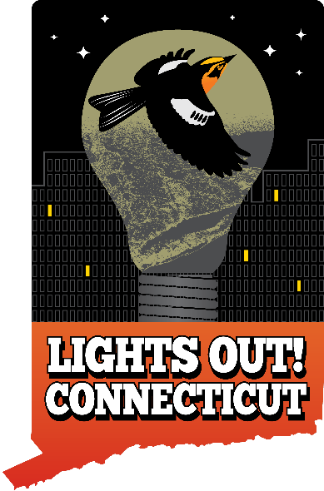

Facebook >> www.facebook.com/lightsoutct/

Instagram >> www.instagram.com/lightsoutct/
LinkedIn >> www.linkedin.com/company/lights-out-connecticut/

Feel free to adapt these texts to your membership – and borrow additional texts from our website and the National Audubon Society’s Lights Out web page.

